**Demo Video:**

**Setup:**

Catroller connects to the computer as a USB keyboard and players bat the balls around to execute keystrokes.

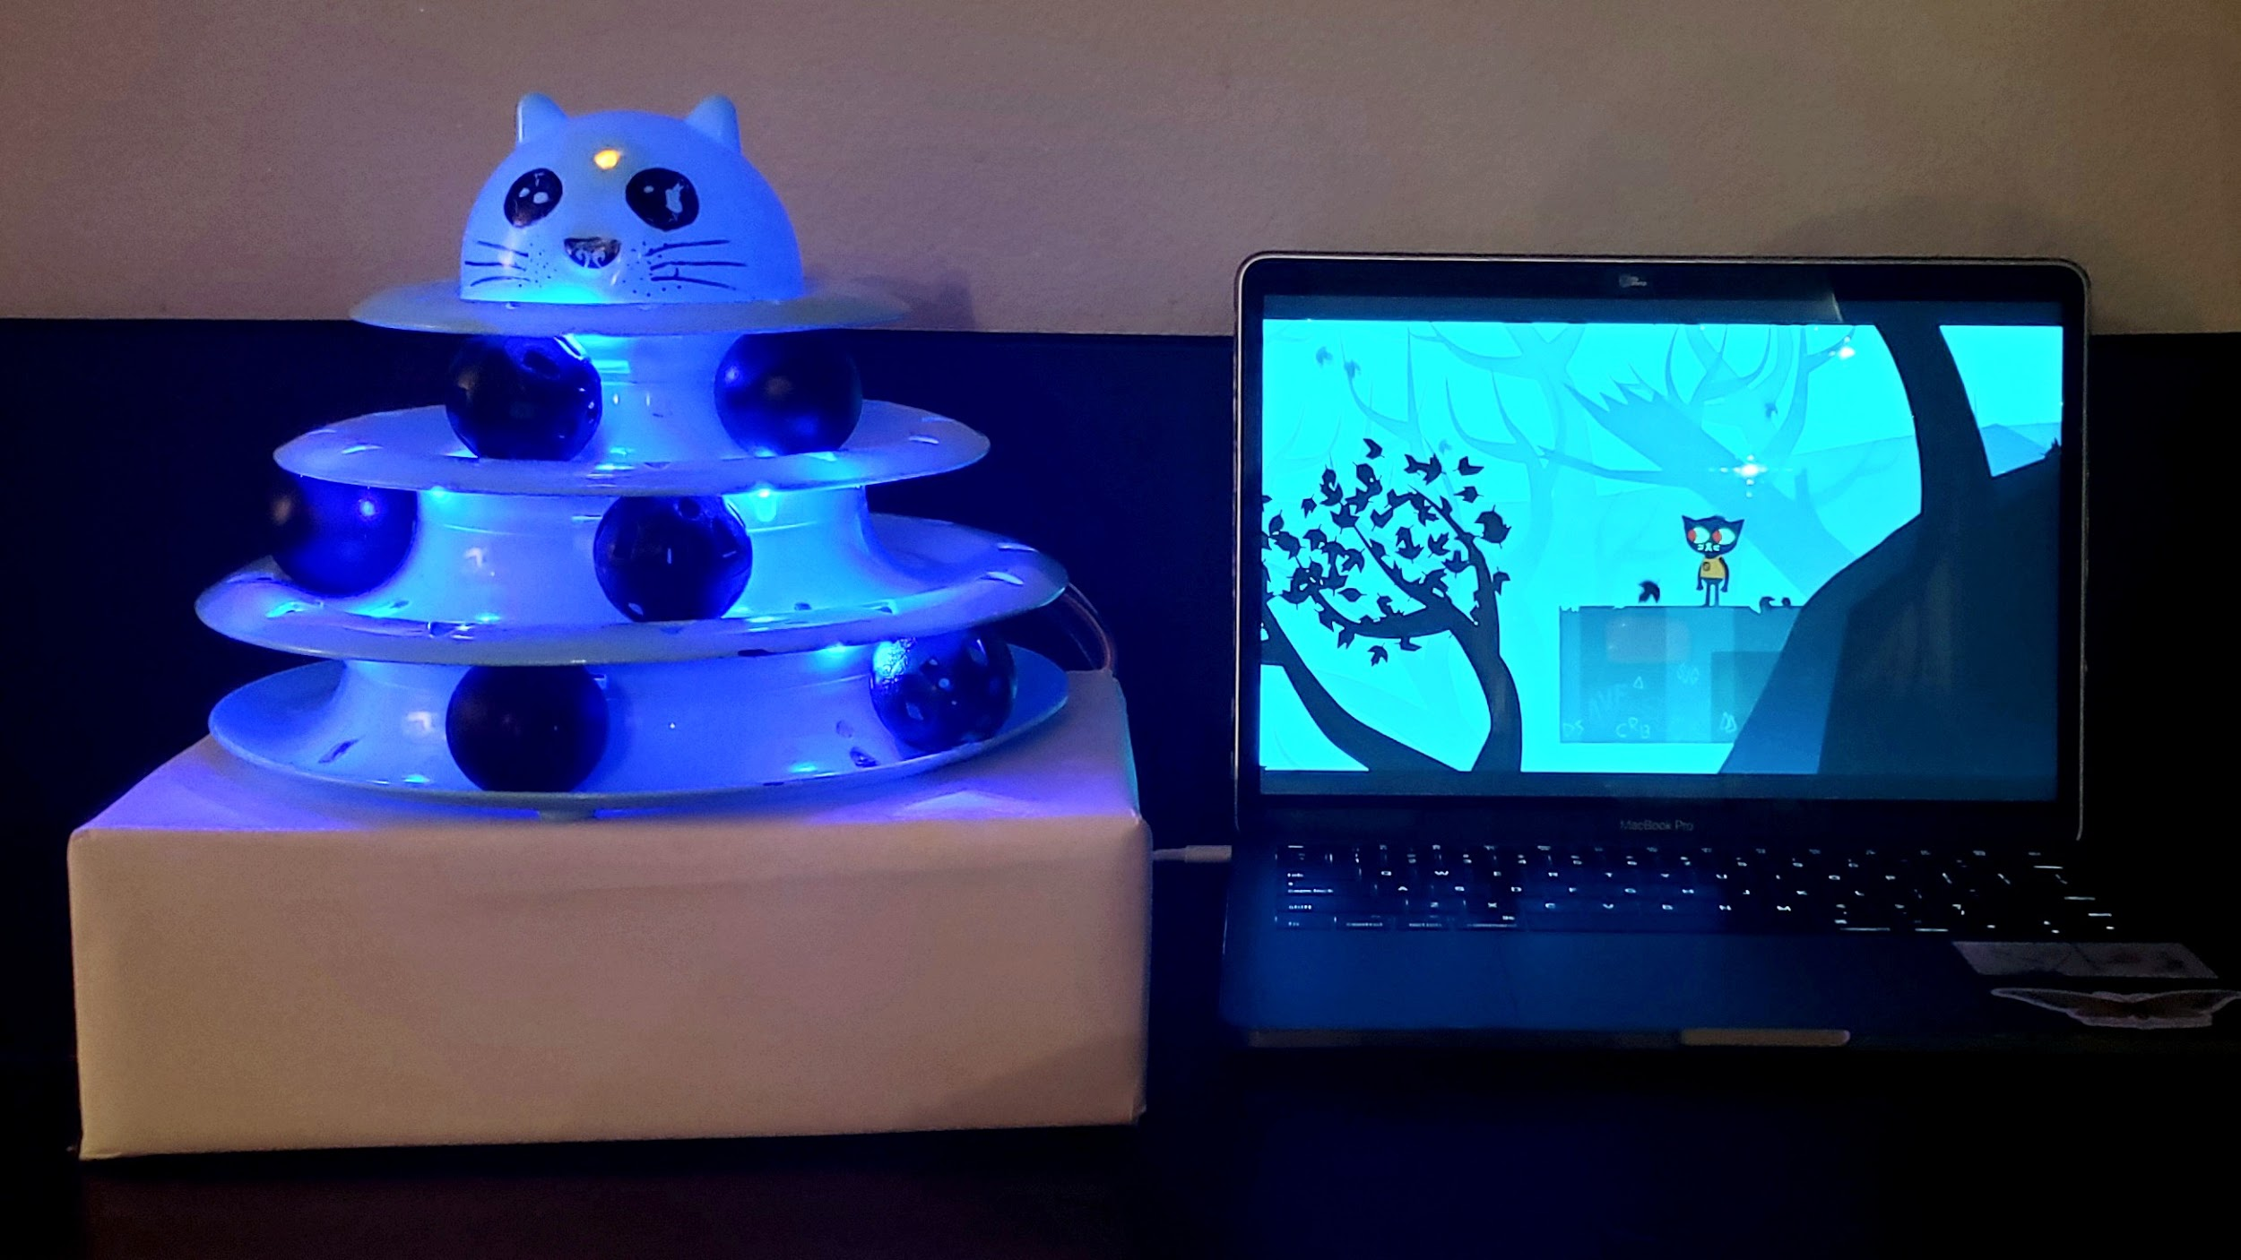

The catroller sits on top of a box with a hole and a hatch in the back for storing the breadboard and the long wires.

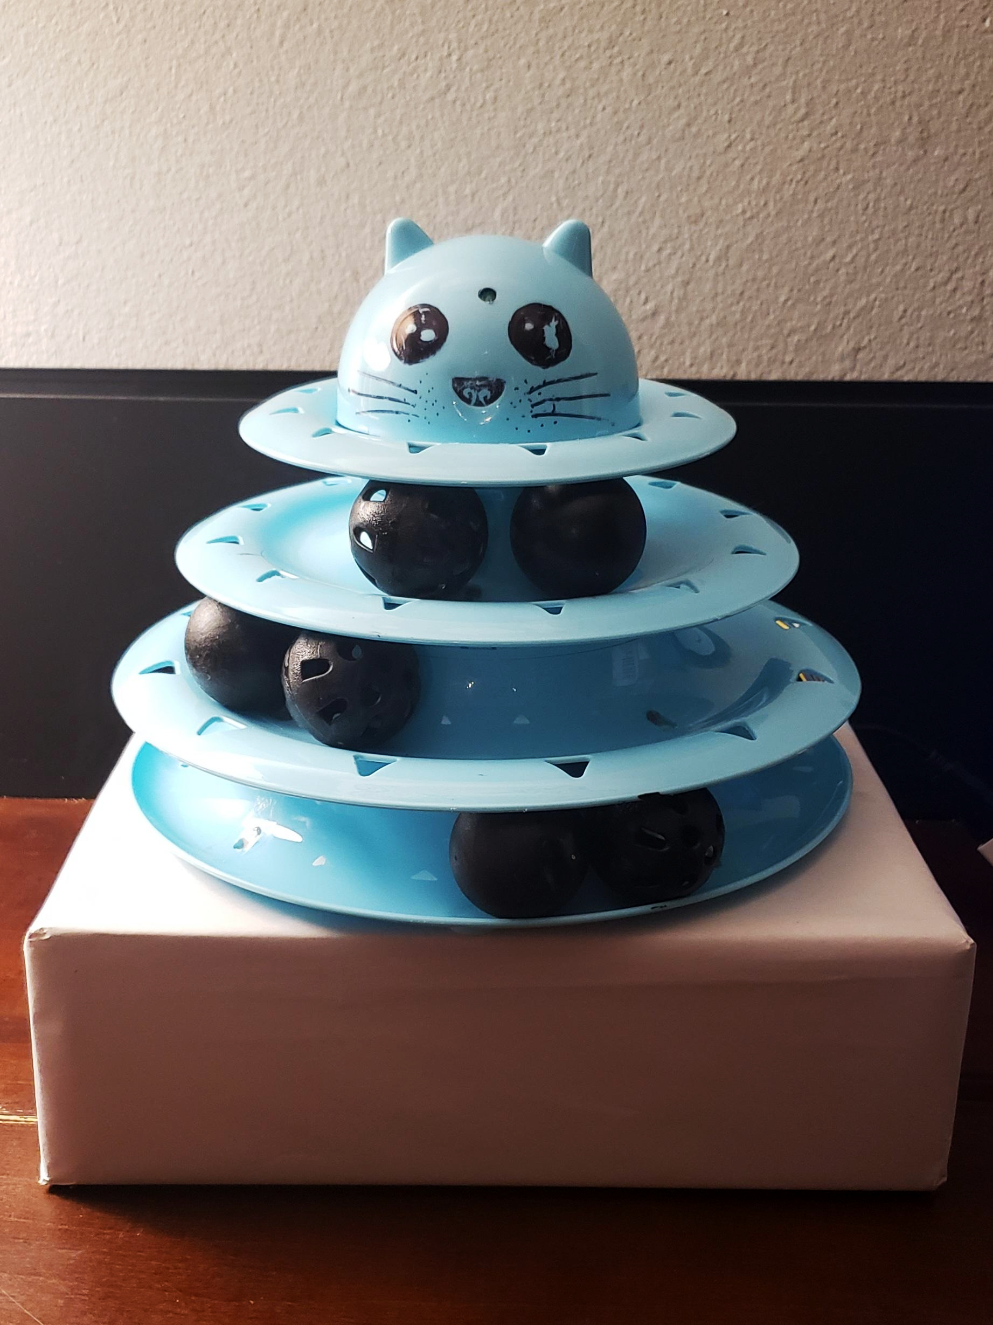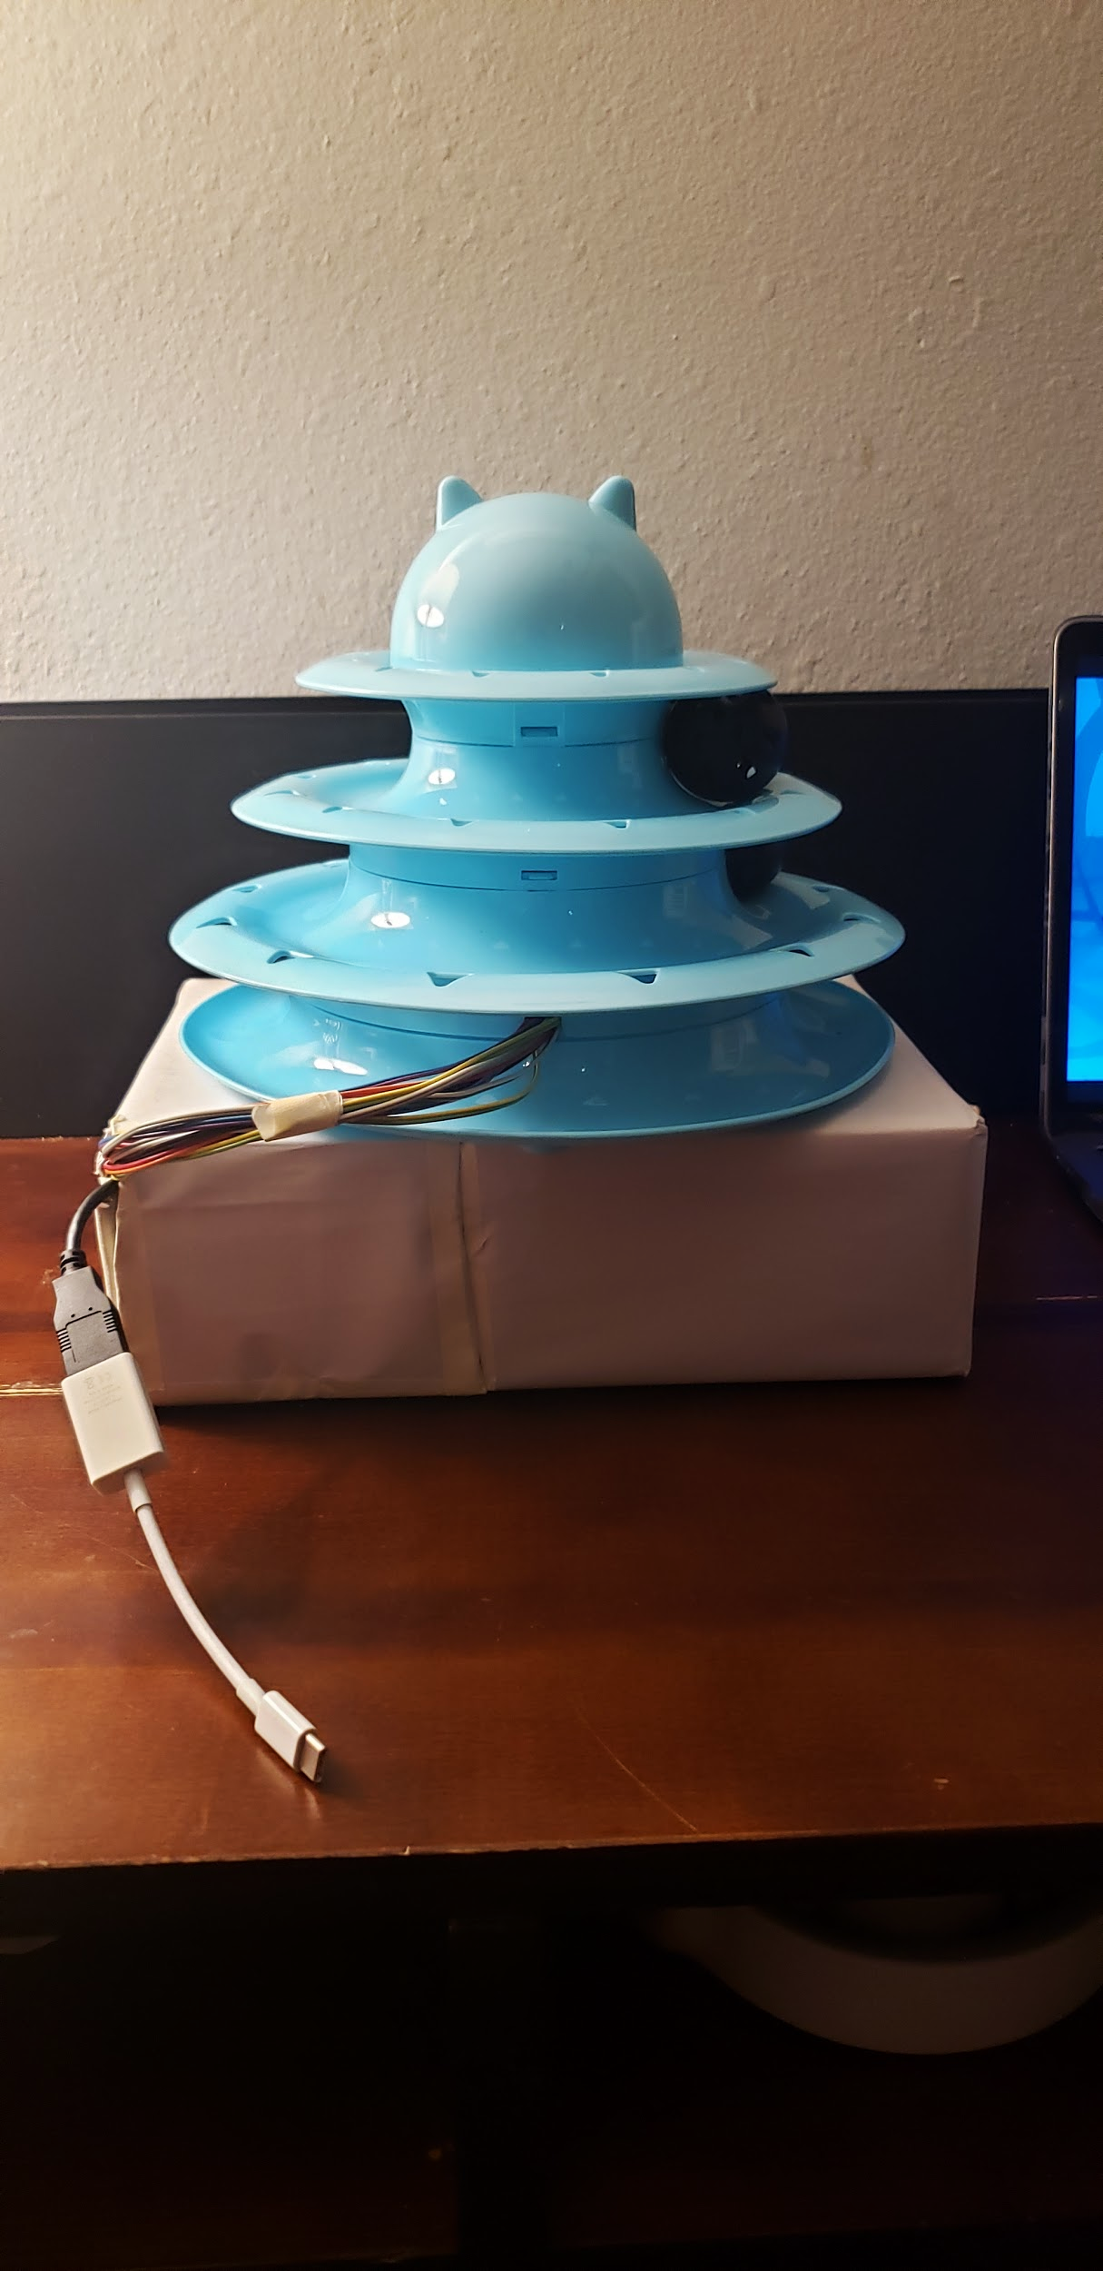

**Circut:**

Uses photoresistors with 10k resistors to send analog voltage differences according to how much light there is. Also features LEDs for lighting and an LED for feedback which blinks when a keystroke is sent. The whole rig is set up using a teensey, photoresistors, leds, a breadboard, and jumpers. Red is power, orange is ground, and blue is analog pins (A0, 16, 17, 20, 22, 23)



**Github Teensey Code:**

<https://github.com/Arvi-56/AltArcade/blob/master/Catroller/final-catroller.ino>

The code sends press keystroke when the ball is on top of the photoresistors and release keystroke when the ball moves away. All the keystrokes and their location is explained in comments and can be changed with the code at the top. At the moment the controller is programmed to WASD and Space.

To calibrate the controller for different rooms with different lighting adjust the darkness threshold to the minimum resistance that is considered to be dark. Higher the threshold, the darker it needs to be to send a keystroke. Although if the threshold is too low it can send keystrokes randomly.